DECISION NOTICE FORM

Policing, Fire and Crime

DN1/YNYCA/M/2026 Date drafted: 24/02/2026
Title: 2026/27 Fire Budget Associated Papers
Request: For approval of the Mayor.
Executive Summary:

The North Yorkshire Fire and Rescue Service budget was approved as part of the Mayoral General Budget at the Combined Authority on the 6th February 2026.

However, beyond the budget there are several other financial papers that ensure that the Fire and Rescue Service operate within defined limits.

These Treasury Management report was considered at the Strategic Oversight Board on the 24th February 2026 by the Deputy Mayor for Policing, Fire and Crime.

While there is no longer a separate Fire Authority in terms of being a standalone Authority, and all the responsibilities of the Fire Authority sit with the Mayoral Combined Authority, there is still separation of many of the financial processes at this stage.
There remain separate Banking functions for Fire, as well as separate and distinct Fire Budgets, including the Capital Programme and associated borrowing.
Within the wider Mayoral Combined Authority structure, it therefore makes sense to continue to set for Fire a separate Annual Treasury Management Strategy Statement for the financial year 2026/27 as well as a separate Reserves Strategy.
This is a Decision Notice outlining these additional papers with the following attached papers:
- 2026-27 Reserves Strategy (Fire)
- 2026-27 Annual Treasury Management Strategy - Fire
  - This report includes the Annual Investment Strategy, the Capital Strategy and the Minimum Revenue Provision Strategy

Decision: It is recommended, by the Assistant Director of Resources (Deputy s73 Officer for Police, Fire and Crime Functions), that the Mayor approves the Reserves Strategy for Fire and the Annual Treasury Management Strategy for Fire for 2026/27 as attached to this Decision
In approving this decision, the Mayor is agreeing to the detailed recommendations contained within both attached papers.
Policing, Fire and Crime (YNYCA) Lead Officer: Michael Porter, Assistant Director of Resources (Deputy s73 Officer for Police, Fire and Crime Functions)
Contractor Details (if applicable): Not applicable

Implications of Decision:
 | Yes | No
Financial | ☒ | ☐
Legal | ☒ | ☐
Equality & Diversity | ☐ | ☒
Human Rights | ☐ | ☒
Sustainability | ☐ | ☒
Risk | ☐ | ☒
If ‘yes’, please provide further details in the following section

IMPLICATIONS - SUPPORTING INFORMATION
Financial Implications:
The Assistant Director of Resources (Deputy s73 Officer for Police, Fire and Crime Functions) has recommended that the Mayor approves the attached papers and in doing so the Mayor will provide the necessary limits in which the Fire Service will operate within during 2026/27 as part of the overall Combined Authority.
Legal Implications: The Director of Legal and Governance (Monitoring Officer) for York and North Yorkshire Combined Authority has advised that all legal and management issues have been addressed.

Equality & Diversity Implications: None arising.
Human Rights Implications: None arising.
Sustainability: None arising.
Risk Management Implications: None arising.

OFFICER APPROVAL
Monitoring Officer:
I have been consulted about the decision and confirm that legal advice has been taken into account. I am satisfied that this is an appropriate request to be submitted to the Deputy Mayor for Policing, Fire and Crime.

Signed: 

Date: 25/02/2026

MAYOR OF YORK AND NORTH YORKSHIRE
The above request has my approval.

Signed: 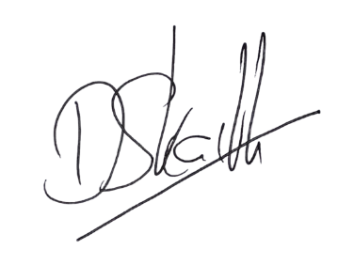

Date: 09/03/2026

