Lead Demand Side Engagement Strategies
(Buyers Club)

1.0 Programme Overview
- The Buyers Club (BC) is a collaborative procurement model being developed to aggregate demand and enable the procurement of high-integrity nature recovery outcomes, linked to strategic regional objectives such as the Local Nature Recovery Strategies (LNRS).It supports public sector authorities and aligned public and private buyers to co-design specifications, share governance, and contract delivery through compliant replicable routes. The model is grounded in the Dynamic Purchasing System (DPS) and complements the LINC programmes ambition to unlock investment in natural capital. The BC also forms one of three mechanisms within the Market Operator Model, alongside the Investment Readiness Facility (IRF) and Demonstration Pilot Projects (DPPs), which together provide the coordinated structure for procurement, investment readiness, and project mobilisation, enabling York and North Yorkshire to attract natural capital investment at scale.
2.0 Programme Aim
- Enable collaborative procurement of nature-based outcomes
- Reduce duplication and build market confidence
- Support locally governed, high-integrity delivery
- Align with regional strategies and national investment frameworks
3.0 Key steps towards (activity)
The diagram below illustrates the steps required in establishing the BC and the expected deliverables at each stage.
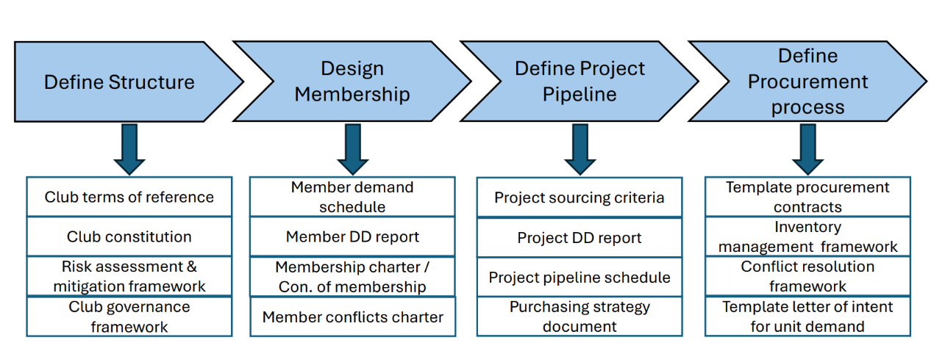
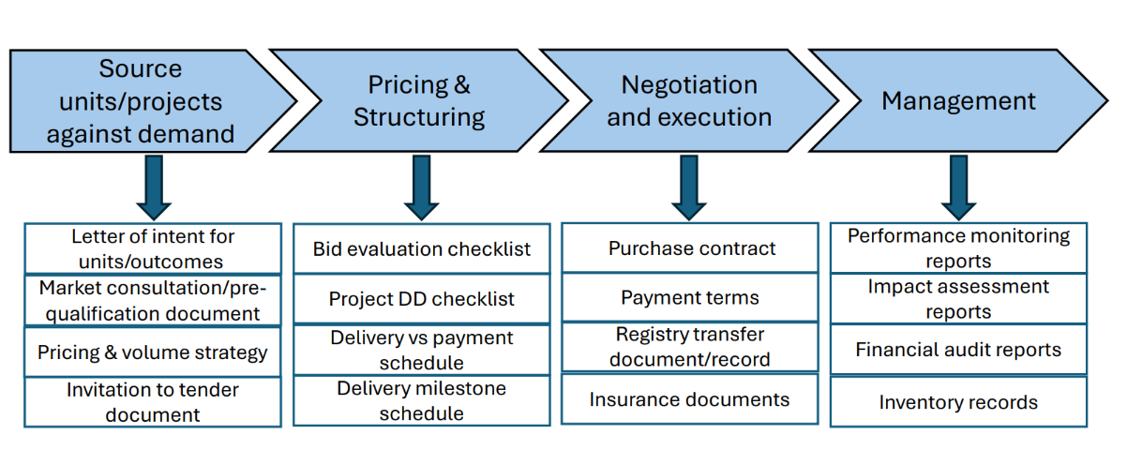

4.0 Key Success Factors for Conducting
None of this can happen without: -
- Clear delivery model aligned with DPS
- Strategic Sequencing that supports governance clarity, investment readiness and replicability
- Local governance ownership to ensure legitimacy, transparency, and long-term stewardship
- Designed for adoption by other local authorities, with governance clarity and delivery integrity maintained
- Integration with existing programmes such as Local Nature Recovery Strategy (LNRS) and wider net zero targets, to ensure alignment with climate and nature recovery priorities
- Use of practical tools including the Green Finance Toolkit to support project selection and investment readiness.
- Blended Finance approach that enables diverse funding sources to support nature recovery and demand-side engagement
5.0 Common Challenges and how to overcome these
Challenge | Recommended Action
Unfamiliarity with the Buyers Club concept across council departments | Develop clear internal briefings that explain the Buyers Club purpose, procurement logic, and how it builds on the DPS system. Use consistent language and practical examples to support cross departmental engagement.
Lack of shared definition of purpose and scope | Establish a clear, shared understanding of the Buyers Club as a demand aggregation model for purchasing ecosystem services. Confirm strategic alignment before progressing to governance or procurement design.
Buyer misalignment or disengagement | Co-design investment principles and document expectations early to build commitment and clarify roles.
Lack of demand analysis to determine local authority requirements | Support local authorities to assess their statutory and strategic demand for ecosystem services. Use spend data, policy commitments, and land use plans to build a demand profile that informs procurement scope and aggregation logic.
Legal and procurement uncertainty | Secure early legal advice and test viable structures and procurement routes – including the Dynamic Purchasing System (DPS) - before progressing to contracting.
Governance complexity in a first-of-a-kind local authority procurement model | Treat governance as a design process. Clarify legal authority, procurement logic, and accountability mechanisms in parallel with structure. Use pilot insights to test and refine replicable models.
Market immaturity or limited supplier readiness | Engage early with project developers to understand delivery models, capacity, and verification needs. Use the DPS to signal demand and build supplier confidence.
Data and evidence gaps for outcome-based contracting | Identify priority outcomes and co-benefits early. Support projects to develop baselines, monitoring plans, and verification methods that meet buyer requirements.
Pricing ambiguity | Develop pricing logic based on market rates, project costs, and buyer thresholds. Include co-benefit valuation and verification costs.
Disconnect between project delivery language and buyer expectations | Develop shared outcome templates and investment principles to clarify what is being purchased. Use facilitation to bridge delivery logic and procurement language.
Risk aversion in public sector procurement | Provide legal and procurement assurance through early advice, peer learning, and alignment with existing frameworks. Use pilots to demonstrate feasibility and manage perceived risk.
Resource constraints | Start pilot with small cohort and prioritise facilitation to maintain momentum.
Difficulty sustaining momentum between concept and contracting | Sequence development stages with clear milestones. Use facilitation to maintain engagement and adapt pace to buyer and project readiness.

6.0 Learning Points
- Define Scope early to avoid duplication a drift and ensure clarity of purpose.
- Lead with governance to establish legitimacy and enable long-term delivery.
- Sequence delivery strategically – timing matters for credibility and uptake.
- Clarify roles and shared language across teams to reduce confusion and accelerate progress.
- Align with statutory and regional priorities to support uptake and integration.
- Use tools that support replicability and investment readiness to embed consistency.
- Undertake demand analysis to inform procurement strategy and senior endorsement to ensure successful delivery during programme development.
- Expect to iterate and refine governance – frameworks will evolve as the programme develops.
- Secure internal political buy-in and senior endorsement to ensure successful delivery during programme development.
7.0 Useful links
Investment Readiness Toolkit
Local Investment in Natural Capital > York and North Yorkshire Combined Authority
Climate change strategy 2023 to 2030 | North Yorkshire Council
Routemap to Carbon Negative > York and North Yorkshire Combined Authority
Investing in Nature for the North – A Strategic Plan for a Nature Positive Regional Economy
How to buy through Dynamic Purchasing Systems - CCS

