York and North Yorkshire
How to:
Establish an
Investment Readiness Facility

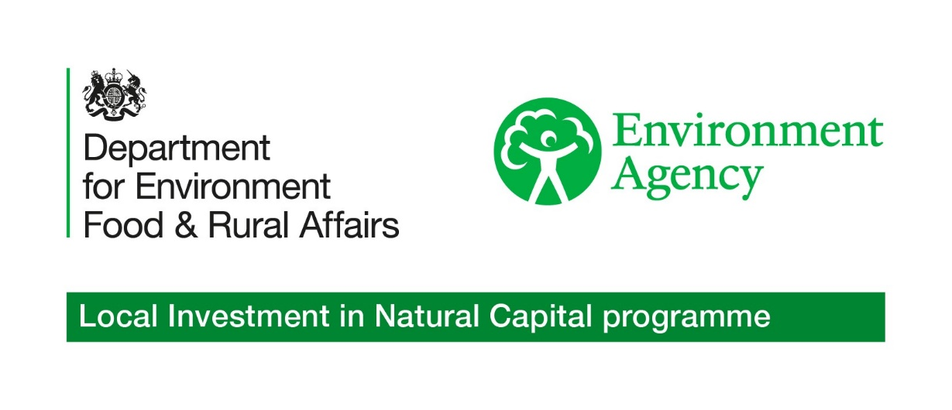

How to establish an Investment Readiness Facility

Contents
1.0 Programme Overview
2.0 Programme Aim
3.0 Introduction
4.0 Role of the Authority
5.0 Finance Structure and Terms
6.0 Project Development
7.0 Delivering the Investment Readiness Facility
8.0 Governance and Oversight
9.0 Scaling Demand and Next Steps
10.0 Glossary

1.0 Programme Overview
- The Investment Readiness Facility (IRF) will offer flexible, repayable finance to support feasibility work, legal structuring, baseline data collection, and other pre-investment activities. It has been developed by the York and North Yorkshire Local Investment in Natural Capital (LINC) programme to help nature recovery projects become investible and meet Buyers Club (BC) sourcing criteria.

- The IRF enables projects to evidence investment readiness and articulate funding requirements to the BC, potential buyers and wider investors. It will be tested through Demonstration Pilot Projects and is designed for scalability and replication across public authority areas. By supporting public sector leadership, the IRF helps shape high-integrity nature markets and unlock investment in locally governed, outcomes-based projects.

- The IRF forms one of three mechanisms within the Market Operator model, alongside the BC and DPP’s, which together provide the coordinated structure for procurement, investment readiness, and project mobilisation.
2.0 Programme Aim
- The IRF provides upfront funding for projects to drive them to investment readiness. It addresses key barriers such as policy uncertainty, demand risk, and limited access to capital – enabling projects to progress toward investment readiness.

- The IRF is designed to complement the BC model by helping projects meet sourcing criteria and align with public sector procurement logic. It supports the development of a credible investible pipeline that reflects local priorities and governance.

- Financial parameters within the IRF are indicative and subject to refinement as pilot activity, procurement processes, and market feedback inform the Authority’s preferred design.
3.0 Introduction
- This guide sits within the Market operator model, which provides the overarching framework through three mechanisms: the IRF, the BC, and DPP’s.

- This document provides strategic guidance for public authorities seeking to operate an IRF to support nature recovery projects. It outlines how the facility can help projects become investment ready, defined as the ability to demonstrate viability, delivery capacity, and alignment with the Investment Readiness Toolkit developed by the Green Finance Institute. This guide proposes potential approaches rather than prescribed requirements and will be refined as delivery models mature.

- The IRF’s financial structure is designed to remain flexible, with scope to evolve in line with programme priorities and market practice, including potential phasing approaches as seen in other regional funds.
4.0 Role of the Authority
- The Authority refers to the public sector body or partnership responsible for designing, managing, and overseeing the IRF. This may include local government combined authorities, or delegated governance structures acting on behalf of the public sector.

- The Authority plays a central role in the operation of the IRF. It is responsible for establishing the facility’s purpose, delivery model, and eligibility criteria: allocating flexible finance, and providing or commissioning advisory input to support project development.

- The Authority ensures the IRF aligns with the BC sourcing criteria, verification standards, and the Investment Readiness Toolkit. The authority tracks project progression toward investment readiness and integrates facility outputs with wider regional and statutory strategies.
5.0 Finance Structure and Terms
- Loan Structure: - The facility may initially offer small grants for early adopters before transitioning, where appropriate, to simple repayable finance. Exact thresholds will be defined as the model develops, with the long-term aim for the facility to transition to simple loans. This approach avoids complex compliance requirements and enables capital to be recycled over time.

- Funding Sources: - Loan capital has been provided by the Department of Environment and Rural Affairs via the Environment Agency. Other sources could include commercial banks, impact investors and public funding bodies each with different repayment expectations.

- Use of Funds: - Loans may fund feasibility studies, permits, Measurement, Reporting and Verification planning, legal support and project structuring. These activities address key barriers such as policy uncertainty, demand risk, stakeholder coordination and limited investment access.

- Loan Amount: - Individual loan limits are yet to be determined but will be set to reflect typical early-stage costs. Final thresholds may be adjusted in line with lender requirements or public funding guidelines.

- Loan Terms: - Loan terms are still to be determined and will be formally agreed through governance processes as the model is implemented.

- Loan Cost: - Commercial loans will be priced at the cost of capital. Public loans will be bench marked against a simple reference rate, such as the Bank of England base rate plus administration costs.

- Project Eligibility: - Projects must meet standard eligibility criteria aligned with carbon (CO₂), Biodiversity Net Gain (BNG) or Natural Flood Management (NFM) methodologies. They must show potential for Ecosystem Service Trading and alignment with Local Investment in Natural Capital (LINC) frameworks.

- Loan Security: - Commercial loans may be secured against future Natural Capital outcomes. Public loans may be unsecured with repayment expected via the Authority (BC) contract or future investment.

- Funding Conditions: - Projects must demonstrate a clear repayment pathway, such as an Authority (BC Contract) or offtake agreement. Public funding may support strategic projects that lack early-stage finance.
6.0 Project Development
- For projects to become investable, IRF funding may be required to support the collection of baseline data, and the development of credible financial models. This could include financing consultancy-led field surveys, hydrological modelling within catchments, or funding experienced in-house staff to carry out soil and habitat assessments. Baseline data is essential to quantify potential uplift, demonstrate project viability, and meet verification requirements in markets such as BNG, CO₂ and NFM.

- A common barrier to project development is the lack of clear pricing and the robust financial models. The IRF may therefore need to fund expert advice on the costing of habitat creation and management works, hydrological interventions, or CO₂ methodologies, as well as associated monitoring and legal fees. This support enables projects to develop credible financial requirements and articulate them to potential buyers, investors or the BC, ensuring locally governed projects can progress toward investment readiness.

- While current market development is focused on BNG, CO_{2,} and NFM, the IRF is designed to support project development across all ecosystem services. Its role is to fund the technical and commercial work needed to evidence outcomes and create investible propositions, regardless of the specific market mechanism.
7.0 Delivering the IRF
- The delivery model for the IRF will depend on local context and available delivery capacity. Key components may include: -

- A delivery team or delegated body responsible for managing the facility
- A clear process for identifying and supporting eligible projects
- Mechanisms for allocating finance and providing advisory input
- Tools for tracking project progression and readiness milestones

- This guide will be updated as delivery models are tested and refined through Demonstration Pilot Projects
8.0 Governance and Oversight
- Governance structures will vary by Combined Authority area, depending on statutory responsibilities and partnership arrangements. Oversight should include: -
- A lead authority responsible for strategic decision-making
- Transparent criteria for finance allocation and project eligibility
- Integration with wider governance frameworks, including Local Nature Recovery Strategies (LNRS)
- Proportionate reporting and accountability mechanisms to support replication.
9.0 Scaling Demand and Next Steps
- The IRF is designed to unlock early-stage project development at scale. As Demonstration Pilot Projects progress, the Facility can be expected to support a broader pipeline of investable nature recovery opportunities.

- Scaling demand will require: -
- Continued engagement with BC partners, project owners and delivery partners
- Clear sourcing logic to identify projects aligned with BC and LINC frameworks
- Ongoing refinement of eligibility criteria, finance terms, and advisory support
- Integration with wider investment planning, including LNRS and regional procurement pathways

- Next steps may include formalising delivery arrangements, testing the facility across multiple Demonstration Pilot Projects, with a view to informing wider replication and scaling.

10.0 Glossary
The Authority: - The public sector body or partnership responsible for designing, managing, and overseeing the Investment Readiness Facility.
Buyer: - An organisation or individual seeking to purchase nature recovery goods and services. This includes local authorities, landowners, and individuals.
Blended Finance: - The combination of grants, concessional funding, and private capital used to support project delivery and testing. Enables risk-sharing and flexible investment in early-stage nature recovery projects.
Buyers Club: - A coordinated group of organisations working together to buy nature recovery goods and services. By sharing a procurement framework, they can pool demand, reduce duplication, and make it easier for suppliers to deliver locally. This approach supports strategic procurement and helps unlock investment in ecosystem services.
Demonstration Pilot Projects: - Nature recovery projects delivering ecosystem services, used to test and refine the Buyers Club concept.
Ecosystem Services: - benefits provided by nature, such as carbon sequestration, biodiversity, water quality and flood mitigation.
Investor: - Organisation or individual providing funding for nature recovery projects with the expectation of a financial return, often linked to measurable environmental outcomes such as carbon, Biodiversity or flood resilience.
Investment Readiness: - A project’s ability to demonstrate viability, delivery capacity, and alignment with the Green Finance Institute’s Investment Readiness Toolkit.
Investment Readiness Facility (IRF): - A support mechanism operated by a public authority to help nature recovery projects become investment ready. It provides flexible finance and advisory input to strengthen viability, delivery capacity, and investor alignment.
Market Operator (MO): - The coordinating framework that brings together three mechanisms: the Investment Readiness Facility, the Buyers Club, and the Demonstration Pilot Projects. It provides structure for procurement, investment readiness, and project mobilisation by connecting buyers, investors, and project owners.
Milestone-Based Payments: - A risk-sharing tool that releases funding in stages based on verified project progress. Supports delivery confidence and validates supply.
Natural Capital: - The stock of natural assets such as soil, water, air and biodiversity, that underpin ecosystem services and economic value.
Nature Market: - A structured system for buying and selling ecosystem services, underpinned by standards, governance and delivery logic.
Regional Equity Fund: - A pooled investment vehicle designed to support nature recovery and climate-related projects across a defined region. It blends public, philanthropic, and private capital to offer repayable finance and equity investment, often aligned with strategic delivery frameworks and regional priorities.
Seller: - An organisation or individual supplying nature recovery goods and services.

